Homework 4 : Problem 2

The second problem involved combining a landscape and a normal map together by using the texture coordinates from the second texture for displacement. The images used for this were:

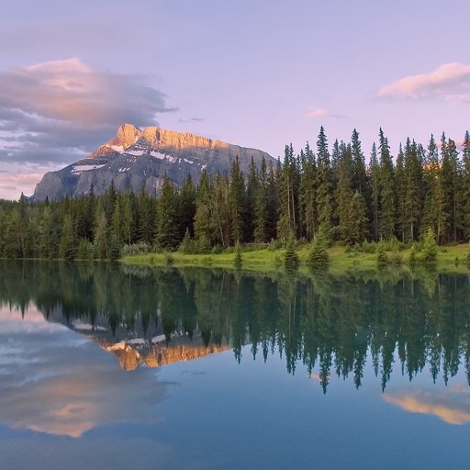 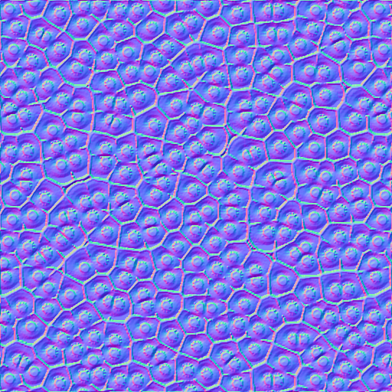

The following are the guidelines for an image to be considered a noise map:

Red from (0-255) to receive X (-1.0 - 1.0)

Green from (0-255) to receive Y (-1.0 - 1.0)

Blue from (0-255) to receive Z (0.0 - 1.0)

Utilizing the sample fragment shader program,

vec2 noiseVec;

noiseVec = normalize(texture(noiseMap, texCoord));

noiseVec = (noiseVec * 2.0 - 1.0) * 0.035;

gl_FragColor = texture(colorMap,

we were able to integrate both the textures together.

Scaling factor: 0.05

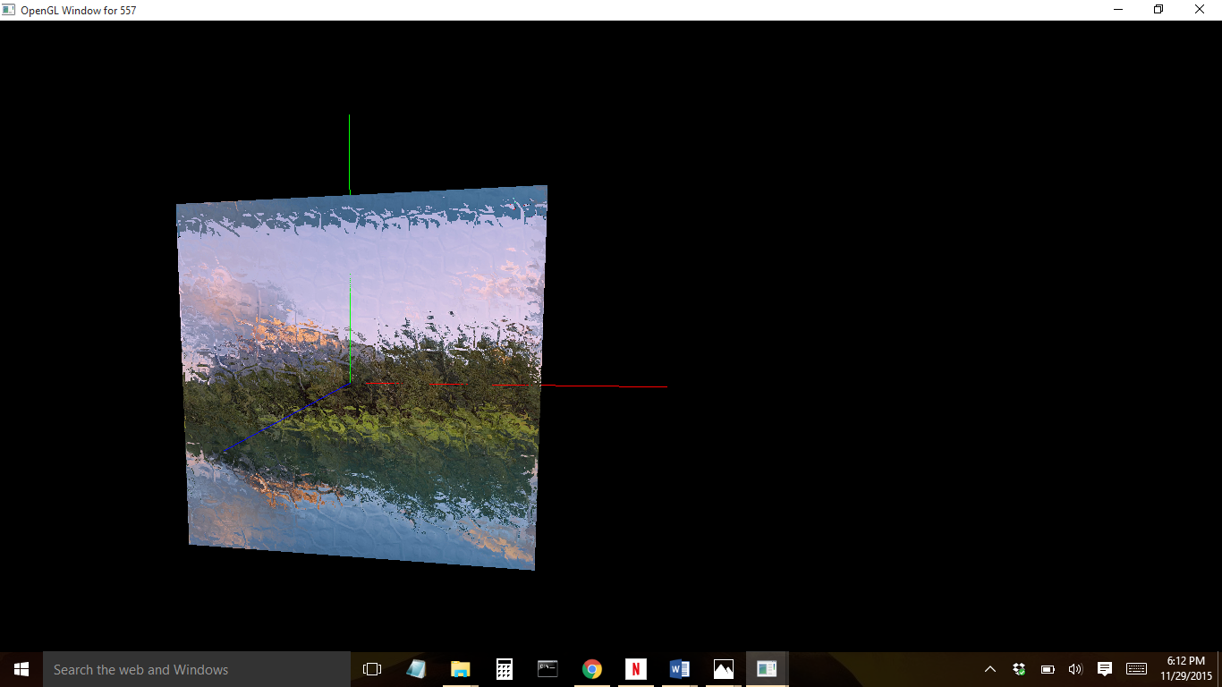

Scaling factor: 0.0035

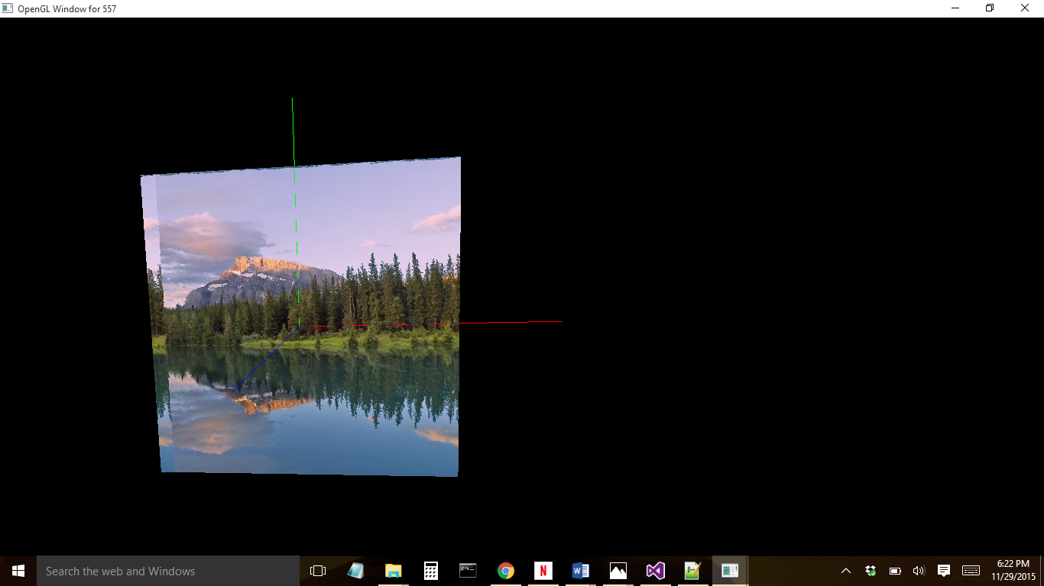

Scaling Factor: 0.00035

